07/01/18 – Unity / Prayer for the Nation

“A CORD OF THREE STRANDS…”
Ecclesiastes 4:12 / John 17:20-23

Ephesians 4:16 MESSAGE - …grow up healthy in God, robust in love.

John 17:1 AMP - …Father...Glorify and exalt and honor and magnify Your Son, so that Your Son may glorify and extol and honor and magnify You.

John 17:21-23 VOICE - Father, may they all be one as You are in Me and I am in You; may they be in Us, for by this unity the world will believe that You sent Me. ²² All the glory You have given to Me, I pass on to them. May that glory unify them and make them one as We are one, ²³ I in them and You in Me, that they may be refined so that all will know that You sent Me, and You love them in the same way You love Me.

Ecclesiastes 4:12 NIV84 - Though one may be overpowered, two can defend themselves. A cord of three strands is not quickly broken.

Ecclesiastes 4:12 NKJV - Though one may be overpowered by another, two can withstand him. And a threefold cord is not quickly broken

Psalm 133 NKJV - Behold, how good and how pleasant it is For brethren to dwell together in unity! ² It is like the precious oil upon the head, Running down on the beard, The beard of Aaron, Running down on the edge of his garments. ³ It is like the dew of Hermon, Descending upon the mountains of Zion; For there the Lord commanded the blessing—Life forevermore.

- Diverse .

Ecclesiastes 4:12 NLT - A person standing alone can be attacked and defeated, but two can stand back-to-back and conquer. Three are even better, for a triple-braided cord is not easily broken.

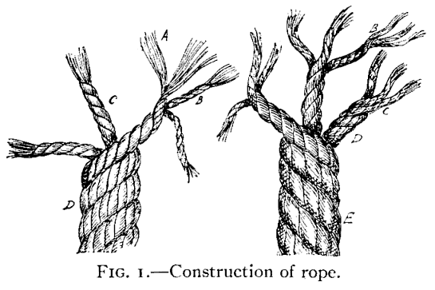

Proverbs 27:17 NIV - As iron sharpens iron, so one man sharpens another.

1 Corinthians 12:27 AMP - Now you [collectively] are Christ's body and [individually] you are members of it, each part severally and distinct [each with his own place and function].

- Increased .

Ecclesiastes 4:12 EXB - …a three-stranded cord does not quickly snap.

Matthew 18:19-20 NIV78 - "Again, I tell you that if two of you on earth agree about anything you ask for, it will be done for you by my Father in heaven. ²⁰ For where two or three come together in my name, there am I with them."

- Loving .

Ecclesiastes 4:12 VOICE - And if one person is vulnerable to attack, two can drive the attacker away. As the saying goes, “A rope made of three strands is not quickly broken.”

Philippians 2:1-2 NIV84 - If you have any encouragement from being united with Christ, if any comfort from his love, if any fellowship with the Spirit, if any tenderness and compassion, ² then make my joy complete by being like-minded, having the same love, being one in spirit and purpose.

Joshua 3:14-17 NLT - So the people left their camp to cross the Jordan, and the priests who were carrying the Ark of the Covenant went ahead of them.¹⁵ It was the harvest season, and the Jordan was overflowing its banks. But as soon as the feet of the priests who were carrying the Ark touched the water at the river’s edge, ¹⁶ the water above that point began backing up a great distance away at a town called Adam, which is near Zarethan. And the water below that point flowed on to the Dead Sea until the riverbed was dry. Then all the people crossed over near the town of Jericho. ¹⁷ Meanwhile, the priests who were carrying the Ark of the Lord’s Covenant stood on dry ground in the middle of the riverbed as the people passed by. They waited there until the whole nation of Israel had crossed the Jordan on dry ground.

John 13:34-35 NIV78 - A new command I give you: Love one another. As I have loved you, so you must love one another. By this all men will know that you are my disciples, if you love one another.

Romans 15:5-7 NIV84 - May the God who gives endurance and encouragement give you a spirit of unity among yourselves as you follow Christ Jesus, ⁶ so that with one heart and mouth you may glorify the God and Father of our Lord Jesus Christ. ⁷ Accept one another, then, just as Christ accepted you, in order to bring praise to God.

